# Comparison between Julia and C++ and their performance

# –

# HPC Project

* Course: AMOD-5420H-A: High-Performance Computing
* 2019SU - Peterborough Campus
* Instructor: Brian Srivastava
* By: Saurabh Bade
* Student id: 0650531

Index:

* Introduction:
* Programming in Julia:
  + Download and installation:
  + Code:
* Programming in C++:
* Comparison:
* Conclusion:
* Appendix:
  + Code of Julia in Chunks:
  + C++ Code:
    - Matrix Operations:
    - File Copy program from 100 small (1MB) files to copy in one file:
    - File Copy program from 100 MB file to copy in another file:

**Introduction:**

A few years back, there were a limited number of computer programming languages on which high-level code could be developed. However, now we have so many programming languages like Fortran, Basic, C, C++, C#, Java or python and so on. One of the newest languages is “Julia”, which was built for the need of scientists and engineers. The first official publication was done 7 years back i.e. in 2012. Julia is considered as one of the strongest languages so far. Hence, in this project, we are going to check the comparison between C++ and Julia. Even we have built some programs in C++ which are faster than Serial Julia. We are going to compare those with Julia anyway.

**Programming in Julia:**

**Download and installation:**

We have to download the Julia package from the official site (<https://julialang.org/downloads/>) as per the platform. For each platform, there is a different package and different way to install. Installation of Julia is easy. It has its own terminal; the screenshot is given below:

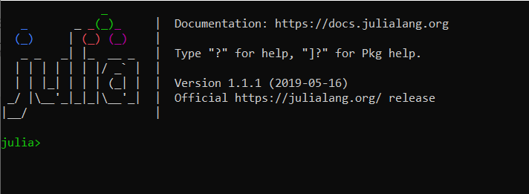

We can even work with Julia in different IDE like ATOM editor, Visual Studio, JetBrains, Vim, Emacs, Sublime text, Revise or in Jupiter Notebook.

**Code:**

We have done coding of Julia in Jupiter notebook. In Maximum code, we have applied time function to check how much time does it takes to execute the chunk of code. Here, I have taken the value of N = 1000. And I will let you know why I haven’t taken 10 thousand.

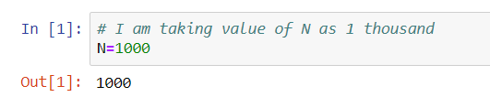

* An array of Integers: here we have taken an array of N values of integers between 1 to 10.

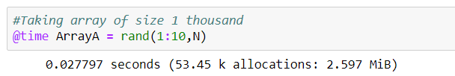

Time is taken to execute this chunk = 0.027797 seconds

* Sum of elements of the array: Here we have taken sum of elements of the array. And the time took was 0.000013 seconds

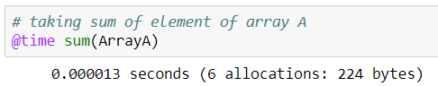

* Creating matrix and Matrix B of element N x N:

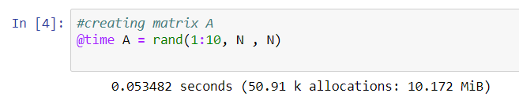

Time taken to create this matrix A = 0.053482, and for matrix B = 0.034162.

* Addition of the matrices: Here we have done the addition of the two matrices i.e. A and B. time taken to execute this code = 0.185976 seconds.

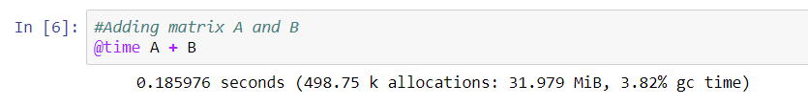

* Sum of the element of matrix A: we have take sum of each element of the matrix, and time is taken to execute this code = 0.046466

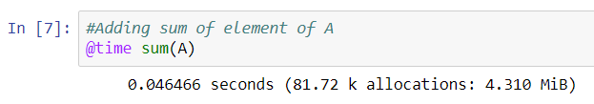

* Sum of diagonal elements of matrix A

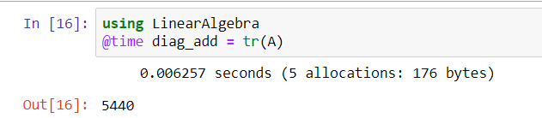

Time is taken to execute this code = 0.006257 seconds

* Multiplication of two matrices and time took to run this code = 1.092619.

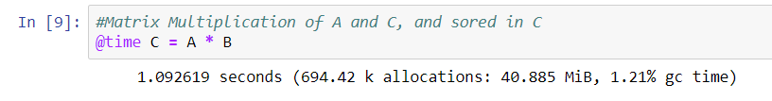

* Now all the above code is taken under a function sumMult() and calculated the time for the same.

Here, the time taken to execute the whole chunk = 0.771434 seconds, which include addition, multiplication, the sum of diagonal element and sum of the element of matrices is given. Now, this code takes less time to execute than the matrix multiplication of matrix A and Matrix B, which was 1.092619 seconds, the difference between these is that we have not added print statement so that all the vales should be printed.

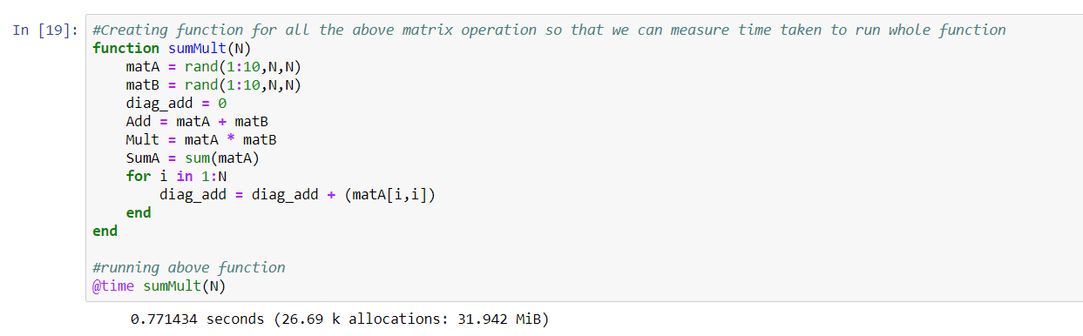

* Creating a file of 101 MB and coping that files content to another file:

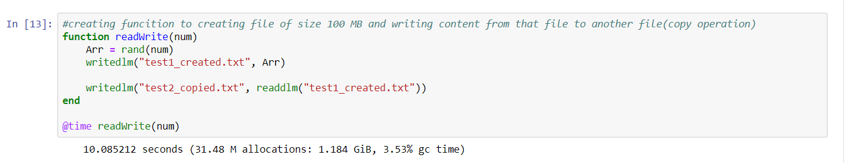

Time taken to execute this code is 10.085212

* Created 100 files of 1MB each so that we can copy from those files in 1 single file.

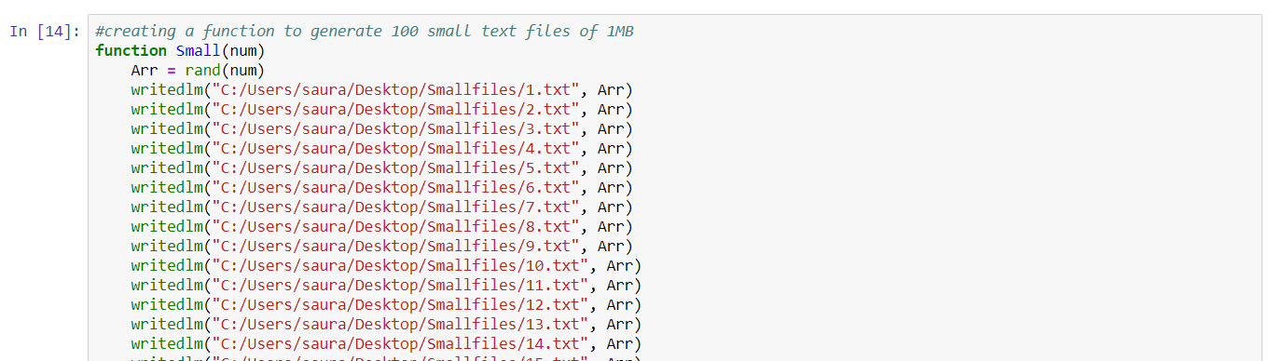



Time is taken to execute 1.573477 seconds.

* Copy content from all small files to one file named: “copiedfromsmall.txt”

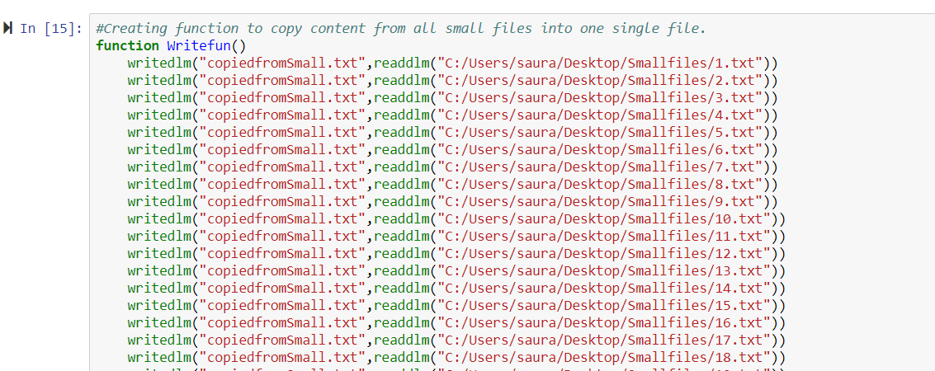



Time taken to execute this program is 7.966173 seconds.

**Programming in C++:**

Now we have implemented some of the code in C++ so that we can compare time difference and performance of the code. The output of the code is given below:

* Matrix Multiplication, Addition of the element and addition of diagonal element and addition of two matrices in C++: this was a serial implementation in C++.

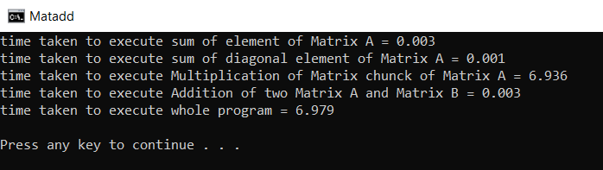

* + Total time has been taken to execute the program = 6.979 seconds.
  + Time has been taken to execute code of matrix addition of Matrix A and Matrix B= 0.003 seconds
  + Time has been taken to execute code of matrix multiplication = 6.936 seconds.
  + Time has been taken to execute code of sum of diagonal element = 0.001 seconds
  + Time has been taken to execute code of sum of element of Matrix A = 0.003 seconds
* Copy from big file to big file and copy from small files to big file:

|  |  |  |  |
| --- | --- | --- | --- |
| **Code chunk name** | **Time taken in Julia(seconds)** | **Time taken in C++ (in seconds)** | **Difference** |
| Sum of Element of Matrix | 0.046466 | 0.003 | 0.043466 |
| Sum of diagonal element of Matrix | 0.006257 | 0.001 | 0.005257 |
| Addition of two matrix | 0.185976 | 0.003 | 0.182976 |
| Multiplication of the matrix | 1.092619 | 6.936 | -5.84338 |
| Time taken to execute whole Matrix(all above operations) program: | 0.771434 | 6.979 | -6.20757 |
| Copy file from large file | 10.085212 | 7.507 | 2.578212 |
| Copy file from several small(1MB) files | 7.966173 | 7.448 | 0.518173 |

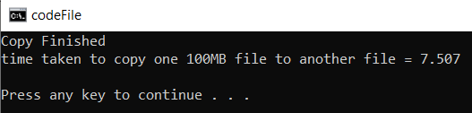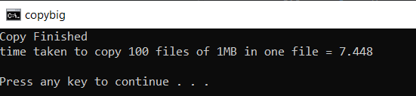

Time has been taken to execute:

* + Part a: copy from 100 small files to big file = 7.448 seconds
  + Part b: copy the big file into another big file = 7.507 seconds

**Comparison:**

In the above two sections, we have implemented some code and have check how much time does it **Comparison table**

take to execute the program. All those results are collected in the comparison table is shown above;

As per the comparison table, we can see the time difference taken by programming language Julia and C++ to execute the chunks of codes.

We can see that C++ s much more efficient than Julia in every way, except the matrix multiplication and hence it is highlighted in red in the difference between Julia and C++ time execution. Just due to matrix Multiplication code, the overall performance of the matrix operation of Julia has increased (row number 5). Also, we can clearly see the huge difference between Julia and C++ for file operations. The difference for 6th row is 2.578212 seconds and for 7th row is 0.518173 seconds

Moreover, I haven’t taken the value of N = 10000 because, when I took that at first, my system gets hung as power utilization was too high by Julia. The screenshot is shown below for the same:

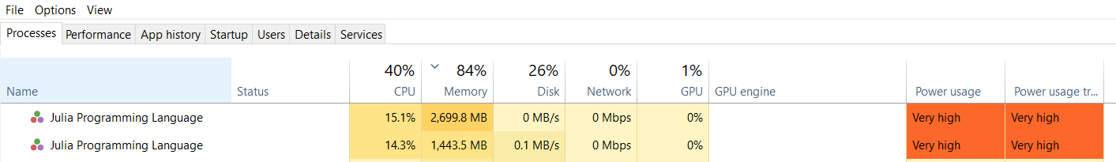

**Conclusion:**

We have checked the results and did the comparison, from which we can conclude that C++ is faster than Julia, however, Julia is faster in some cases like Matrix multiplication. Moreover, Julia has high power usage and hence which harm system. As C++ is an orthodox programming language, and hard to code, but Julia is easy to code and available on all platform as the C++ too. Surely, as per the performance, C++ is still faster than Julia and hence Julia developer needs to come with a more optimized version of Julia as this is still a new language.

**Appendix:**

**Code of Julia in Chunks:**

|  |
| --- |
| # I am taking value of N as 1 thousand  global N=1000 |
| #Taking array of size 1 thousand  @time ArrayA = rand(1:10,N) |
| # taking sum of element of array A  @time sum(ArrayA) |
| #creating matrix A  @time A = rand(1:10, N , N) |
| #Creating matrix B  @time B = rand(1:10, N, N) |
| #Adding matrix A and B  @time A + B |
| #Adding sum of element of A  @time sum(A) |
| #sum of diagonal element of matrix A  global diag_sum=0  for i in 1:N  diag_sum = diag_sum + (A[i,i])  end  diag_sum |
| using LinearAlgebra  @time diag_add = tr(A) |
| #Matrix Multiplication of A and C, and sored in C  @time C = A * B |
| #Creating function for all the above matrix operation so that we can measure time taken to run whole function  function sumMult(N)  matA = rand(1:10,N,N)  matB = rand(1:10,N,N)  diag_add = 0  Add = matA + matB  Mult = matA * matB  SumA = sum(matA)  for i in 1:N  diag_add = diag_add + (matA[i,i])  end  end  #running above function  @time sumMult(N) |
| using DelimitedFiles  num = 5507226  small = 55072 |
| #creating funcition to creating file of size 100 MB and writing content from that file to another file(copy operation)  function readWrite(num)  Arr = rand(num)  writedlm("test1_created.txt", Arr)    writedlm("test2_copied.txt", readdlm("test1_created.txt"))  end  @time readWrite(num) |
| #creating a function to generate 100 small text files of 1MB  function Small(num)  Arr = rand(num)  writedlm("C:/Users/saura/Desktop/Smallfiles/1.txt", Arr)  writedlm("C:/Users/saura/Desktop/Smallfiles/2.txt", Arr)  writedlm("C:/Users/saura/Desktop/Smallfiles/3.txt", Arr)  writedlm("C:/Users/saura/Desktop/Smallfiles/4.txt", Arr)  writedlm("C:/Users/saura/Desktop/Smallfiles/5.txt", Arr)  writedlm("C:/Users/saura/Desktop/Smallfiles/6.txt", Arr)  writedlm("C:/Users/saura/Desktop/Smallfiles/7.txt", Arr)  writedlm("C:/Users/saura/Desktop/Smallfiles/8.txt", Arr)  writedlm("C:/Users/saura/Desktop/Smallfiles/9.txt", Arr)  writedlm("C:/Users/saura/Desktop/Smallfiles/10.txt", Arr)  writedlm("C:/Users/saura/Desktop/Smallfiles/11.txt", Arr)  writedlm("C:/Users/saura/Desktop/Smallfiles/12.txt", Arr)  writedlm("C:/Users/saura/Desktop/Smallfiles/13.txt", Arr)  writedlm("C:/Users/saura/Desktop/Smallfiles/14.txt", Arr)  writedlm("C:/Users/saura/Desktop/Smallfiles/15.txt", Arr)  writedlm("C:/Users/saura/Desktop/Smallfiles/16.txt", Arr)  writedlm("C:/Users/saura/Desktop/Smallfiles/17.txt", Arr)  writedlm("C:/Users/saura/Desktop/Smallfiles/18.txt", Arr)  writedlm("C:/Users/saura/Desktop/Smallfiles/19.txt", Arr)  writedlm("C:/Users/saura/Desktop/Smallfiles/20.txt", Arr)  writedlm("C:/Users/saura/Desktop/Smallfiles/21.txt", Arr)  writedlm("C:/Users/saura/Desktop/Smallfiles/22.txt", Arr)  writedlm("C:/Users/saura/Desktop/Smallfiles/23.txt", Arr)  writedlm("C:/Users/saura/Desktop/Smallfiles/24.txt", Arr)  writedlm("C:/Users/saura/Desktop/Smallfiles/25.txt", Arr)  writedlm("C:/Users/saura/Desktop/Smallfiles/26.txt", Arr)  writedlm("C:/Users/saura/Desktop/Smallfiles/27.txt", Arr)  writedlm("C:/Users/saura/Desktop/Smallfiles/28.txt", Arr)  writedlm("C:/Users/saura/Desktop/Smallfiles/29.txt", Arr)  writedlm("C:/Users/saura/Desktop/Smallfiles/30.txt", Arr)  writedlm("C:/Users/saura/Desktop/Smallfiles/31.txt", Arr)  writedlm("C:/Users/saura/Desktop/Smallfiles/32.txt", Arr)  writedlm("C:/Users/saura/Desktop/Smallfiles/33.txt", Arr)  writedlm("C:/Users/saura/Desktop/Smallfiles/34.txt", Arr)  writedlm("C:/Users/saura/Desktop/Smallfiles/35.txt", Arr)  writedlm("C:/Users/saura/Desktop/Smallfiles/36.txt", Arr)  writedlm("C:/Users/saura/Desktop/Smallfiles/37.txt", Arr)  writedlm("C:/Users/saura/Desktop/Smallfiles/38.txt", Arr)  writedlm("C:/Users/saura/Desktop/Smallfiles/39.txt", Arr)  writedlm("C:/Users/saura/Desktop/Smallfiles/40.txt", Arr)  writedlm("C:/Users/saura/Desktop/Smallfiles/41.txt", Arr)  writedlm("C:/Users/saura/Desktop/Smallfiles/42.txt", Arr)  writedlm("C:/Users/saura/Desktop/Smallfiles/43.txt", Arr)  writedlm("C:/Users/saura/Desktop/Smallfiles/44.txt", Arr)  writedlm("C:/Users/saura/Desktop/Smallfiles/45.txt", Arr)  writedlm("C:/Users/saura/Desktop/Smallfiles/46.txt", Arr)  writedlm("C:/Users/saura/Desktop/Smallfiles/47.txt", Arr)  writedlm("C:/Users/saura/Desktop/Smallfiles/48.txt", Arr)  writedlm("C:/Users/saura/Desktop/Smallfiles/49.txt", Arr)  writedlm("C:/Users/saura/Desktop/Smallfiles/50.txt", Arr)  writedlm("C:/Users/saura/Desktop/Smallfiles/51.txt", Arr)  writedlm("C:/Users/saura/Desktop/Smallfiles/52.txt", Arr)  writedlm("C:/Users/saura/Desktop/Smallfiles/53.txt", Arr)  writedlm("C:/Users/saura/Desktop/Smallfiles/54.txt", Arr)  writedlm("C:/Users/saura/Desktop/Smallfiles/55.txt", Arr)  writedlm("C:/Users/saura/Desktop/Smallfiles/56.txt", Arr)  writedlm("C:/Users/saura/Desktop/Smallfiles/57.txt", Arr)  writedlm("C:/Users/saura/Desktop/Smallfiles/58.txt", Arr)  writedlm("C:/Users/saura/Desktop/Smallfiles/59.txt", Arr)  writedlm("C:/Users/saura/Desktop/Smallfiles/60.txt", Arr)  writedlm("C:/Users/saura/Desktop/Smallfiles/61.txt", Arr)  writedlm("C:/Users/saura/Desktop/Smallfiles/62.txt", Arr)  writedlm("C:/Users/saura/Desktop/Smallfiles/63.txt", Arr)  writedlm("C:/Users/saura/Desktop/Smallfiles/64.txt", Arr)  writedlm("C:/Users/saura/Desktop/Smallfiles/65.txt", Arr)  writedlm("C:/Users/saura/Desktop/Smallfiles/66.txt", Arr)  writedlm("C:/Users/saura/Desktop/Smallfiles/67.txt", Arr)  writedlm("C:/Users/saura/Desktop/Smallfiles/68.txt", Arr)  writedlm("C:/Users/saura/Desktop/Smallfiles/69.txt", Arr)  writedlm("C:/Users/saura/Desktop/Smallfiles/70.txt", Arr)  writedlm("C:/Users/saura/Desktop/Smallfiles/71.txt", Arr)  writedlm("C:/Users/saura/Desktop/Smallfiles/72.txt", Arr)  writedlm("C:/Users/saura/Desktop/Smallfiles/73.txt", Arr)  writedlm("C:/Users/saura/Desktop/Smallfiles/74.txt", Arr)  writedlm("C:/Users/saura/Desktop/Smallfiles/75.txt", Arr)  writedlm("C:/Users/saura/Desktop/Smallfiles/76.txt", Arr)  writedlm("C:/Users/saura/Desktop/Smallfiles/77.txt", Arr)  writedlm("C:/Users/saura/Desktop/Smallfiles/78.txt", Arr)  writedlm("C:/Users/saura/Desktop/Smallfiles/79.txt", Arr)  writedlm("C:/Users/saura/Desktop/Smallfiles/80.txt", Arr)  writedlm("C:/Users/saura/Desktop/Smallfiles/81.txt", Arr)  writedlm("C:/Users/saura/Desktop/Smallfiles/82.txt", Arr)  writedlm("C:/Users/saura/Desktop/Smallfiles/83.txt", Arr)  writedlm("C:/Users/saura/Desktop/Smallfiles/84.txt", Arr)  writedlm("C:/Users/saura/Desktop/Smallfiles/85.txt", Arr)  writedlm("C:/Users/saura/Desktop/Smallfiles/86.txt", Arr)  writedlm("C:/Users/saura/Desktop/Smallfiles/87.txt", Arr)  writedlm("C:/Users/saura/Desktop/Smallfiles/88.txt", Arr)  writedlm("C:/Users/saura/Desktop/Smallfiles/89.txt", Arr)  writedlm("C:/Users/saura/Desktop/Smallfiles/90.txt", Arr)  writedlm("C:/Users/saura/Desktop/Smallfiles/91.txt", Arr)  writedlm("C:/Users/saura/Desktop/Smallfiles/92.txt", Arr)  writedlm("C:/Users/saura/Desktop/Smallfiles/93.txt", Arr)  writedlm("C:/Users/saura/Desktop/Smallfiles/94.txt", Arr)  writedlm("C:/Users/saura/Desktop/Smallfiles/95.txt", Arr)  writedlm("C:/Users/saura/Desktop/Smallfiles/96.txt", Arr)  writedlm("C:/Users/saura/Desktop/Smallfiles/97.txt", Arr)  writedlm("C:/Users/saura/Desktop/Smallfiles/98.txt", Arr)  writedlm("C:/Users/saura/Desktop/Smallfiles/99.txt", Arr)  writedlm("C:/Users/saura/Desktop/Smallfiles/100.txt", Arr)  end  @time Small(small) |
| #Creating function to copy content from all small files into one single file.  function Writefun()  writedlm("copiedfromSmall.txt",readdlm("C:/Users/saura/Desktop/Smallfiles/1.txt"))  writedlm("copiedfromSmall.txt",readdlm("C:/Users/saura/Desktop/Smallfiles/2.txt"))  writedlm("copiedfromSmall.txt",readdlm("C:/Users/saura/Desktop/Smallfiles/3.txt"))  writedlm("copiedfromSmall.txt",readdlm("C:/Users/saura/Desktop/Smallfiles/4.txt"))  writedlm("copiedfromSmall.txt",readdlm("C:/Users/saura/Desktop/Smallfiles/5.txt"))  writedlm("copiedfromSmall.txt",readdlm("C:/Users/saura/Desktop/Smallfiles/6.txt"))  writedlm("copiedfromSmall.txt",readdlm("C:/Users/saura/Desktop/Smallfiles/7.txt"))  writedlm("copiedfromSmall.txt",readdlm("C:/Users/saura/Desktop/Smallfiles/8.txt"))  writedlm("copiedfromSmall.txt",readdlm("C:/Users/saura/Desktop/Smallfiles/9.txt"))  writedlm("copiedfromSmall.txt",readdlm("C:/Users/saura/Desktop/Smallfiles/10.txt"))  writedlm("copiedfromSmall.txt",readdlm("C:/Users/saura/Desktop/Smallfiles/11.txt"))  writedlm("copiedfromSmall.txt",readdlm("C:/Users/saura/Desktop/Smallfiles/12.txt"))  writedlm("copiedfromSmall.txt",readdlm("C:/Users/saura/Desktop/Smallfiles/13.txt"))  writedlm("copiedfromSmall.txt",readdlm("C:/Users/saura/Desktop/Smallfiles/14.txt"))  writedlm("copiedfromSmall.txt",readdlm("C:/Users/saura/Desktop/Smallfiles/15.txt"))  writedlm("copiedfromSmall.txt",readdlm("C:/Users/saura/Desktop/Smallfiles/16.txt"))  writedlm("copiedfromSmall.txt",readdlm("C:/Users/saura/Desktop/Smallfiles/17.txt"))  writedlm("copiedfromSmall.txt",readdlm("C:/Users/saura/Desktop/Smallfiles/18.txt"))  writedlm("copiedfromSmall.txt",readdlm("C:/Users/saura/Desktop/Smallfiles/19.txt"))  writedlm("copiedfromSmall.txt",readdlm("C:/Users/saura/Desktop/Smallfiles/20.txt"))  writedlm("copiedfromSmall.txt",readdlm("C:/Users/saura/Desktop/Smallfiles/21.txt"))  writedlm("copiedfromSmall.txt",readdlm("C:/Users/saura/Desktop/Smallfiles/22.txt"))  writedlm("copiedfromSmall.txt",readdlm("C:/Users/saura/Desktop/Smallfiles/23.txt"))  writedlm("copiedfromSmall.txt",readdlm("C:/Users/saura/Desktop/Smallfiles/24.txt"))  writedlm("copiedfromSmall.txt",readdlm("C:/Users/saura/Desktop/Smallfiles/25.txt"))  writedlm("copiedfromSmall.txt",readdlm("C:/Users/saura/Desktop/Smallfiles/26.txt"))  writedlm("copiedfromSmall.txt",readdlm("C:/Users/saura/Desktop/Smallfiles/27.txt"))  writedlm("copiedfromSmall.txt",readdlm("C:/Users/saura/Desktop/Smallfiles/28.txt"))  writedlm("copiedfromSmall.txt",readdlm("C:/Users/saura/Desktop/Smallfiles/29.txt"))  writedlm("copiedfromSmall.txt",readdlm("C:/Users/saura/Desktop/Smallfiles/30.txt"))  writedlm("copiedfromSmall.txt",readdlm("C:/Users/saura/Desktop/Smallfiles/31.txt"))  writedlm("copiedfromSmall.txt",readdlm("C:/Users/saura/Desktop/Smallfiles/32.txt"))  writedlm("copiedfromSmall.txt",readdlm("C:/Users/saura/Desktop/Smallfiles/33.txt"))  writedlm("copiedfromSmall.txt",readdlm("C:/Users/saura/Desktop/Smallfiles/34.txt"))  writedlm("copiedfromSmall.txt",readdlm("C:/Users/saura/Desktop/Smallfiles/35.txt"))  writedlm("copiedfromSmall.txt",readdlm("C:/Users/saura/Desktop/Smallfiles/36.txt"))  writedlm("copiedfromSmall.txt",readdlm("C:/Users/saura/Desktop/Smallfiles/37.txt"))  writedlm("copiedfromSmall.txt",readdlm("C:/Users/saura/Desktop/Smallfiles/38.txt"))  writedlm("copiedfromSmall.txt",readdlm("C:/Users/saura/Desktop/Smallfiles/39.txt"))  writedlm("copiedfromSmall.txt",readdlm("C:/Users/saura/Desktop/Smallfiles/40.txt"))  writedlm("copiedfromSmall.txt",readdlm("C:/Users/saura/Desktop/Smallfiles/41.txt"))  writedlm("copiedfromSmall.txt",readdlm("C:/Users/saura/Desktop/Smallfiles/42.txt"))  writedlm("copiedfromSmall.txt",readdlm("C:/Users/saura/Desktop/Smallfiles/43.txt"))  writedlm("copiedfromSmall.txt",readdlm("C:/Users/saura/Desktop/Smallfiles/44.txt"))  writedlm("copiedfromSmall.txt",readdlm("C:/Users/saura/Desktop/Smallfiles/45.txt"))  writedlm("copiedfromSmall.txt",readdlm("C:/Users/saura/Desktop/Smallfiles/46.txt"))  writedlm("copiedfromSmall.txt",readdlm("C:/Users/saura/Desktop/Smallfiles/47.txt"))  writedlm("copiedfromSmall.txt",readdlm("C:/Users/saura/Desktop/Smallfiles/48.txt"))  writedlm("copiedfromSmall.txt",readdlm("C:/Users/saura/Desktop/Smallfiles/49.txt"))  writedlm("copiedfromSmall.txt",readdlm("C:/Users/saura/Desktop/Smallfiles/50.txt"))  writedlm("copiedfromSmall.txt",readdlm("C:/Users/saura/Desktop/Smallfiles/51.txt"))  writedlm("copiedfromSmall.txt",readdlm("C:/Users/saura/Desktop/Smallfiles/52.txt"))  writedlm("copiedfromSmall.txt",readdlm("C:/Users/saura/Desktop/Smallfiles/53.txt"))  writedlm("copiedfromSmall.txt",readdlm("C:/Users/saura/Desktop/Smallfiles/54.txt"))  writedlm("copiedfromSmall.txt",readdlm("C:/Users/saura/Desktop/Smallfiles/55.txt"))  writedlm("copiedfromSmall.txt",readdlm("C:/Users/saura/Desktop/Smallfiles/56.txt"))  writedlm("copiedfromSmall.txt",readdlm("C:/Users/saura/Desktop/Smallfiles/57.txt"))  writedlm("copiedfromSmall.txt",readdlm("C:/Users/saura/Desktop/Smallfiles/58.txt"))  writedlm("copiedfromSmall.txt",readdlm("C:/Users/saura/Desktop/Smallfiles/59.txt"))  writedlm("copiedfromSmall.txt",readdlm("C:/Users/saura/Desktop/Smallfiles/60.txt"))  writedlm("copiedfromSmall.txt",readdlm("C:/Users/saura/Desktop/Smallfiles/61.txt"))  writedlm("copiedfromSmall.txt",readdlm("C:/Users/saura/Desktop/Smallfiles/62.txt"))  writedlm("copiedfromSmall.txt",readdlm("C:/Users/saura/Desktop/Smallfiles/63.txt"))  writedlm("copiedfromSmall.txt",readdlm("C:/Users/saura/Desktop/Smallfiles/64.txt"))  writedlm("copiedfromSmall.txt",readdlm("C:/Users/saura/Desktop/Smallfiles/65.txt"))  writedlm("copiedfromSmall.txt",readdlm("C:/Users/saura/Desktop/Smallfiles/66.txt"))  writedlm("copiedfromSmall.txt",readdlm("C:/Users/saura/Desktop/Smallfiles/67.txt"))  writedlm("copiedfromSmall.txt",readdlm("C:/Users/saura/Desktop/Smallfiles/68.txt"))  writedlm("copiedfromSmall.txt",readdlm("C:/Users/saura/Desktop/Smallfiles/69.txt"))  writedlm("copiedfromSmall.txt",readdlm("C:/Users/saura/Desktop/Smallfiles/70.txt"))  writedlm("copiedfromSmall.txt",readdlm("C:/Users/saura/Desktop/Smallfiles/71.txt"))  writedlm("copiedfromSmall.txt",readdlm("C:/Users/saura/Desktop/Smallfiles/72.txt"))  writedlm("copiedfromSmall.txt",readdlm("C:/Users/saura/Desktop/Smallfiles/73.txt"))  writedlm("copiedfromSmall.txt",readdlm("C:/Users/saura/Desktop/Smallfiles/74.txt"))  writedlm("copiedfromSmall.txt",readdlm("C:/Users/saura/Desktop/Smallfiles/75.txt"))  writedlm("copiedfromSmall.txt",readdlm("C:/Users/saura/Desktop/Smallfiles/76.txt"))  writedlm("copiedfromSmall.txt",readdlm("C:/Users/saura/Desktop/Smallfiles/77.txt"))  writedlm("copiedfromSmall.txt",readdlm("C:/Users/saura/Desktop/Smallfiles/78.txt"))  writedlm("copiedfromSmall.txt",readdlm("C:/Users/saura/Desktop/Smallfiles/79.txt"))  writedlm("copiedfromSmall.txt",readdlm("C:/Users/saura/Desktop/Smallfiles/80.txt"))  writedlm("copiedfromSmall.txt",readdlm("C:/Users/saura/Desktop/Smallfiles/81.txt"))  writedlm("copiedfromSmall.txt",readdlm("C:/Users/saura/Desktop/Smallfiles/82.txt"))  writedlm("copiedfromSmall.txt",readdlm("C:/Users/saura/Desktop/Smallfiles/83.txt"))  writedlm("copiedfromSmall.txt",readdlm("C:/Users/saura/Desktop/Smallfiles/84.txt"))  writedlm("copiedfromSmall.txt",readdlm("C:/Users/saura/Desktop/Smallfiles/85.txt"))  writedlm("copiedfromSmall.txt",readdlm("C:/Users/saura/Desktop/Smallfiles/86.txt"))  writedlm("copiedfromSmall.txt",readdlm("C:/Users/saura/Desktop/Smallfiles/87.txt"))  writedlm("copiedfromSmall.txt",readdlm("C:/Users/saura/Desktop/Smallfiles/88.txt"))  writedlm("copiedfromSmall.txt",readdlm("C:/Users/saura/Desktop/Smallfiles/89.txt"))  writedlm("copiedfromSmall.txt",readdlm("C:/Users/saura/Desktop/Smallfiles/90.txt"))  writedlm("copiedfromSmall.txt",readdlm("C:/Users/saura/Desktop/Smallfiles/91.txt"))  writedlm("copiedfromSmall.txt",readdlm("C:/Users/saura/Desktop/Smallfiles/92.txt"))  writedlm("copiedfromSmall.txt",readdlm("C:/Users/saura/Desktop/Smallfiles/93.txt"))  writedlm("copiedfromSmall.txt",readdlm("C:/Users/saura/Desktop/Smallfiles/94.txt"))  writedlm("copiedfromSmall.txt",readdlm("C:/Users/saura/Desktop/Smallfiles/95.txt"))  writedlm("copiedfromSmall.txt",readdlm("C:/Users/saura/Desktop/Smallfiles/96.txt"))  writedlm("copiedfromSmall.txt",readdlm("C:/Users/saura/Desktop/Smallfiles/97.txt"))  writedlm("copiedfromSmall.txt",readdlm("C:/Users/saura/Desktop/Smallfiles/98.txt"))  writedlm("copiedfromSmall.txt",readdlm("C:/Users/saura/Desktop/Smallfiles/99.txt"))  writedlm("copiedfromSmall.txt",readdlm("C:/Users/saura/Desktop/Smallfiles/100.txt"))  end  #using the function  @time Writefun() |

**C++ Code:**

**Matrix Operations:**

|  |
| --- |
| #include <iostream>  #include <cmath>  #include <cstdlib>  #include <ctime>  #include <time.h>  int main ()  {  int sum=0,  diagsum=0,  local_sum,  local_diag,  N = 1000;  clock_t t1, t2;  t2 = clock();  int** arrayA = new int*[N]; //declaring array dynamically.  int** arrayB = new int*[N];  int** MultAxB = new int*[N];  for(int m=0;m<N;++m)  {  arrayA[m] = new int[N];  }  for(int m=0;m<N;++m)  {  arrayB[m] = new int[N];  }  for(int m=0;m<N;++m)  {  MultAxB[m] = new int[N];  }  srand (time(NULL));  //Creating matrix A of size rowSize x colSize with random of first 30  for(int i = 0;i<N;++i)  {  for(int j = 0;j<N;++j)  {  arrayA[i][j]=rand() % 10;  }  }  for(int i = 0;i<N;++i)  {  for(int j = 0;j<N;++j)  {  arrayB[i][j]=rand() % 10;  }  }  {  local_sum = 0;  local_diag=0;  //sum of element of the matrix  t1 = clock();  for(int i = 0;i<N;i++)  {  for(int j=0;j<N;j++)  {  sum = sum + arrayA[i][j];  }  }  std::cout << "time taken to execute sum of element of Matrix A = " << (double)(clock()-t1)/CLOCKS_PER_SEC << '\n';  t1 = clock();  for(int j=0;j<N;j++)  {  diagsum = diagsum + arrayA[j][j];  }  std::cout << "time taken to execute sum of diagonal element of Matrix A = " << (double)(clock()-t1)/CLOCKS_PER_SEC << '\n';  //multiplication of mat A and mat B  t1 = clock();  {  for(int i = 0; i < N; ++i)  {  for(int j = 0; j < N; ++j)  {  for(int k = 0; k < N; ++k)  {  MultAxB[i][j] += arrayA[i][k] * arrayB[k][j];  }  }  }  }  std::cout << "time taken to execute Multiplication of Matrix chunck of Matrix A = " << (double)(clock()-t1)/CLOCKS_PER_SEC << '\n';  t1 = clock();  for(int i = 0;i<N;i++)  {  for(int j=0;j<N;j++)  {  arrayB[i][j] = arrayB[i][j] + arrayA[i][j];  }  }  std::cout << "time taken to execute Addition of two Matrix A and Matrix B = " << (double)(clock()-t1)/CLOCKS_PER_SEC << '\n';  for(int m=0;m<N;m++)  {  delete[] arrayA[m];  }  for(int m=0;m<N;m++)  {  delete[] arrayB[m];  }  for(int m=0;m<N;m++)  {  delete[] MultAxB[m];  }  delete[] arrayA;  delete[] arrayB;  delete[] MultAxB;  std::cout << "time taken to execute whole program = " << (double)(clock()-t2)/CLOCKS_PER_SEC <<'\n';  return 0;  }  } |

**File Copy program from 100 small (1MB) files to copy in one file:**

|  |
| --- |
| #include <iostream>  #include <fstream>  #include <ctime>  #include <time.h>  using namespace std;  int main()  {  string line;  clock_t t1, t2;  //For writing text file  //Creating ofstream & ifstream class object  t1 = clock();  ifstream file1 ("1.txt");  ifstream file2 ("2.txt");  ifstream file3 ("3.txt");  ifstream file4 ("4.txt");  ifstream file5 ("5.txt");  ifstream file6 ("6.txt");  ifstream file7 ("7.txt");  ifstream file8 ("8.txt");  ifstream file9 ("9.txt");  ifstream file10 ("10.txt");  ifstream file11 ("11.txt");  ifstream file12 ("12.txt");  ifstream file13 ("13.txt");  ifstream file14 ("14.txt");  ifstream file15 ("15.txt");  ifstream file16 ("16.txt");  ifstream file17 ("17.txt");  ifstream file18 ("18.txt");  ifstream file19 ("19.txt");  ifstream file20 ("20.txt");  ifstream file21 ("21.txt");  ifstream file22 ("22.txt");  ifstream file23 ("23.txt");  ifstream file24 ("24.txt");  ifstream file25 ("25.txt");  ifstream file26 ("26.txt");  ifstream file27 ("27.txt");  ifstream file28 ("28.txt");  ifstream file29 ("29.txt");  ifstream file30 ("30.txt");  ifstream file31 ("31.txt");  ifstream file32 ("32.txt");  ifstream file33 ("33.txt");  ifstream file34 ("34.txt");  ifstream file35 ("35.txt");  ifstream file36 ("36.txt");  ifstream file37 ("37.txt");  ifstream file38 ("38.txt");  ifstream file39 ("39.txt");  ifstream file40 ("40.txt");  ifstream file41 ("41.txt");  ifstream file42 ("42.txt");  ifstream file43 ("43.txt");  ifstream file44 ("44.txt");  ifstream file45 ("45.txt");  ifstream file46 ("46.txt");  ifstream file47 ("47.txt");  ifstream file48 ("48.txt");  ifstream file49 ("49.txt");  ifstream file50 ("50.txt");  ifstream file51 ("51.txt");  ifstream file52 ("52.txt");  ifstream file53 ("53.txt");  ifstream file54 ("54.txt");  ifstream file55 ("55.txt");  ifstream file56 ("56.txt");  ifstream file57 ("57.txt");  ifstream file58 ("58.txt");  ifstream file59 ("59.txt");  ifstream file60 ("60.txt");  ifstream file61 ("61.txt");  ifstream file62 ("62.txt");  ifstream file63 ("63.txt");  ifstream file64 ("64.txt");  ifstream file65 ("65.txt");  ifstream file66 ("66.txt");  ifstream file67 ("67.txt");  ifstream file68 ("68.txt");  ifstream file69 ("69.txt");  ifstream file70 ("70.txt");  ifstream file71 ("71.txt");  ifstream file72 ("72.txt");  ifstream file73 ("73.txt");  ifstream file74 ("74.txt");  ifstream file75 ("75.txt");  ifstream file76 ("76.txt");  ifstream file77 ("77.txt");  ifstream file78 ("78.txt");  ifstream file79 ("79.txt");  ifstream file80 ("80.txt");  ifstream file81 ("81.txt");  ifstream file82 ("82.txt");  ifstream file83 ("83.txt");  ifstream file84 ("84.txt");  ifstream file85 ("85.txt");  ifstream file86 ("86.txt");  ifstream file87 ("87.txt");  ifstream file88 ("88.txt");  ifstream file89 ("89.txt");  ifstream file90 ("90.txt");  ifstream file91 ("91.txt");  ifstream file92 ("92.txt");  ifstream file93 ("93.txt");  ifstream file94 ("94.txt");  ifstream file95 ("95.txt");  ifstream file96 ("96.txt");  ifstream file97 ("97.txt");  ifstream file98 ("98.txt");  ifstream file99 ("99.txt");  ifstream file100 ("100.txt");  ofstream outFile2 ("NewFilefromSmall.txt");  if(file1 &&  file2 &&  file3 &&  file4 &&  file5 &&  file6 &&  file7 &&  file8 &&  file9 &&  file10 &&  file11 &&  file12 &&  file13 &&  file14 &&  file15 &&  file16 &&  file17 &&  file18 &&  file19 &&  file20 &&  file21 &&  file22 &&  file23 &&  file24 &&  file25 &&  file26 &&  file27 &&  file28 &&  file29 &&  file30 &&  file31 &&  file32 &&  file33 &&  file34 &&  file35 &&  file36 &&  file37 &&  file38 &&  file39 &&  file40 &&  file41 &&  file42 &&  file43 &&  file44 &&  file45 &&  file46 &&  file47 &&  file48 &&  file49 &&  file50 &&  file51 &&  file52 &&  file53 &&  file54 &&  file55 &&  file56 &&  file57 &&  file58 &&  file59 &&  file60 &&  file61 &&  file62 &&  file63 &&  file64 &&  file65 &&  file66 &&  file67 &&  file68 &&  file69 &&  file70 &&  file71 &&  file72 &&  file73 &&  file74 &&  file75 &&  file76 &&  file77 &&  file78 &&  file79 &&  file80 &&  file81 &&  file82 &&  file83 &&  file84 &&  file85 &&  file86 &&  file87 &&  file88 &&  file89 &&  file90 &&  file91 &&  file92 &&  file93 &&  file94 &&  file95 &&  file96 &&  file97 &&  file98 &&  file99 &&  file100 &&  outFile2){  //while(getline(inputFile,line)){outFile2 << line << "\n";}  while(getline(file1,line)){outFile2 << line << "\n";}  while(getline(file2,line)){outFile2 << line << "\n";}  while(getline(file3,line)){outFile2 << line << "\n";}  while(getline(file4,line)){outFile2 << line << "\n";}  while(getline(file5,line)){outFile2 << line << "\n";}  while(getline(file6,line)){outFile2 << line << "\n";}  while(getline(file7,line)){outFile2 << line << "\n";}  while(getline(file8,line)){outFile2 << line << "\n";}  while(getline(file9,line)){outFile2 << line << "\n";}  while(getline(file10,line)){outFile2 << line << "\n";}  while(getline(file11,line)){outFile2 << line << "\n";}  while(getline(file12,line)){outFile2 << line << "\n";}  while(getline(file13,line)){outFile2 << line << "\n";}  while(getline(file14,line)){outFile2 << line << "\n";}  while(getline(file15,line)){outFile2 << line << "\n";}  while(getline(file16,line)){outFile2 << line << "\n";}  while(getline(file17,line)){outFile2 << line << "\n";}  while(getline(file18,line)){outFile2 << line << "\n";}  while(getline(file19,line)){outFile2 << line << "\n";}  while(getline(file20,line)){outFile2 << line << "\n";}  while(getline(file21,line)){outFile2 << line << "\n";}  while(getline(file22,line)){outFile2 << line << "\n";}  while(getline(file23,line)){outFile2 << line << "\n";}  while(getline(file24,line)){outFile2 << line << "\n";}  while(getline(file25,line)){outFile2 << line << "\n";}  while(getline(file26,line)){outFile2 << line << "\n";}  while(getline(file27,line)){outFile2 << line << "\n";}  while(getline(file28,line)){outFile2 << line << "\n";}  while(getline(file29,line)){outFile2 << line << "\n";}  while(getline(file30,line)){outFile2 << line << "\n";}  while(getline(file31,line)){outFile2 << line << "\n";}  while(getline(file32,line)){outFile2 << line << "\n";}  while(getline(file33,line)){outFile2 << line << "\n";}  while(getline(file34,line)){outFile2 << line << "\n";}  while(getline(file35,line)){outFile2 << line << "\n";}  while(getline(file36,line)){outFile2 << line << "\n";}  while(getline(file37,line)){outFile2 << line << "\n";}  while(getline(file38,line)){outFile2 << line << "\n";}  while(getline(file39,line)){outFile2 << line << "\n";}  while(getline(file40,line)){outFile2 << line << "\n";}  while(getline(file41,line)){outFile2 << line << "\n";}  while(getline(file42,line)){outFile2 << line << "\n";}  while(getline(file43,line)){outFile2 << line << "\n";}  while(getline(file44,line)){outFile2 << line << "\n";}  while(getline(file45,line)){outFile2 << line << "\n";}  while(getline(file46,line)){outFile2 << line << "\n";}  while(getline(file47,line)){outFile2 << line << "\n";}  while(getline(file48,line)){outFile2 << line << "\n";}  while(getline(file49,line)){outFile2 << line << "\n";}  while(getline(file50,line)){outFile2 << line << "\n";}  while(getline(file51,line)){outFile2 << line << "\n";}  while(getline(file52,line)){outFile2 << line << "\n";}  while(getline(file53,line)){outFile2 << line << "\n";}  while(getline(file54,line)){outFile2 << line << "\n";}  while(getline(file55,line)){outFile2 << line << "\n";}  while(getline(file56,line)){outFile2 << line << "\n";}  while(getline(file57,line)){outFile2 << line << "\n";}  while(getline(file58,line)){outFile2 << line << "\n";}  while(getline(file59,line)){outFile2 << line << "\n";}  while(getline(file60,line)){outFile2 << line << "\n";}  while(getline(file61,line)){outFile2 << line << "\n";}  while(getline(file62,line)){outFile2 << line << "\n";}  while(getline(file63,line)){outFile2 << line << "\n";}  while(getline(file64,line)){outFile2 << line << "\n";}  while(getline(file65,line)){outFile2 << line << "\n";}  while(getline(file66,line)){outFile2 << line << "\n";}  while(getline(file67,line)){outFile2 << line << "\n";}  while(getline(file68,line)){outFile2 << line << "\n";}  while(getline(file69,line)){outFile2 << line << "\n";}  while(getline(file70,line)){outFile2 << line << "\n";}  while(getline(file71,line)){outFile2 << line << "\n";}  while(getline(file72,line)){outFile2 << line << "\n";}  while(getline(file73,line)){outFile2 << line << "\n";}  while(getline(file74,line)){outFile2 << line << "\n";}  while(getline(file75,line)){outFile2 << line << "\n";}  while(getline(file76,line)){outFile2 << line << "\n";}  while(getline(file77,line)){outFile2 << line << "\n";}  while(getline(file78,line)){outFile2 << line << "\n";}  while(getline(file79,line)){outFile2 << line << "\n";}  while(getline(file80,line)){outFile2 << line << "\n";}  while(getline(file81,line)){outFile2 << line << "\n";}  while(getline(file82,line)){outFile2 << line << "\n";}  while(getline(file83,line)){outFile2 << line << "\n";}  while(getline(file84,line)){outFile2 << line << "\n";}  while(getline(file85,line)){outFile2 << line << "\n";}  while(getline(file86,line)){outFile2 << line << "\n";}  while(getline(file87,line)){outFile2 << line << "\n";}  while(getline(file88,line)){outFile2 << line << "\n";}  while(getline(file89,line)){outFile2 << line << "\n";}  while(getline(file90,line)){outFile2 << line << "\n";}  while(getline(file91,line)){outFile2 << line << "\n";}  while(getline(file92,line)){outFile2 << line << "\n";}  while(getline(file93,line)){outFile2 << line << "\n";}  while(getline(file94,line)){outFile2 << line << "\n";}  while(getline(file95,line)){outFile2 << line << "\n";}  while(getline(file96,line)){outFile2 << line << "\n";}  while(getline(file97,line)){outFile2 << line << "\n";}  while(getline(file98,line)){outFile2 << line << "\n";}  while(getline(file99,line)){outFile2 << line << "\n";}  while(getline(file100,line)){outFile2 << line << "\n";}  cout << "Copy Finished \n";  }  else  {  //Something went wrong  printf("Cannot read File");  }  //Closing file  file1.close();  file2.close();  file3.close();  file4.close();  file5.close();  file6.close();  file7.close();  file8.close();  file9.close();  file10.close();  file11.close();  file12.close();  file13.close();  file14.close();  file15.close();  file16.close();  file17.close();  file18.close();  file19.close();  file20.close();  file21.close();  file22.close();  file23.close();  file24.close();  file25.close();  file26.close();  file27.close();  file28.close();  file29.close();  file30.close();  file31.close();  file32.close();  file33.close();  file34.close();  file35.close();  file36.close();  file37.close();  file38.close();  file39.close();  file40.close();  file41.close();  file42.close();  file43.close();  file44.close();  file45.close();  file46.close();  file47.close();  file48.close();  file49.close();  file50.close();  file51.close();  file52.close();  file53.close();  file54.close();  file55.close();  file56.close();  file57.close();  file58.close();  file59.close();  file60.close();  file61.close();  file62.close();  file63.close();  file64.close();  file65.close();  file66.close();  file67.close();  file68.close();  file69.close();  file70.close();  file71.close();  file72.close();  file73.close();  file74.close();  file75.close();  file76.close();  file77.close();  file78.close();  file79.close();  file80.close();  file81.close();  file82.close();  file83.close();  file84.close();  file85.close();  file86.close();  file87.close();  file88.close();  file89.close();  file90.close();  file91.close();  file92.close();  file93.close();  file94.close();  file95.close();  file96.close();  file97.close();  file98.close();  file99.close();  file100.close();  outFile2.close();  t2 = clock();  std::cout << "time taken to copy 100 files of 1MB in one file = " << (double)(t2-t1)/CLOCKS_PER_SEC <<'\n';  return 0;  } |

**File Copy program from 100 MB file to copy in another file:**

|  |
| --- |
| #include <iostream>  #include <fstream>  #include <ctime>  #include <time.h>  using namespace std;  int main()  {  string line;  clock_t t1, t2;  //For writing text file  //Creating ofstream & ifstream class object  t1 = clock();  ifstream inputFile ("test1_created.txt");  ofstream outFile2 ("NewFile.txt");  if(inputFile && outFile2){  while(getline(inputFile,line)){  outFile2 << line << "\n";  }  cout << "Copy Finished \n";  } else {  //Something went wrong  printf("Cannot read File");  }  //Closing file  inputFile.close();  outFile2.close();  t2 = clock();  std::cout << "time taken to copy one 100MB file to another file = " << (double)(t2-t1)/CLOCKS_PER_SEC <<'\n';  return 0;  } |